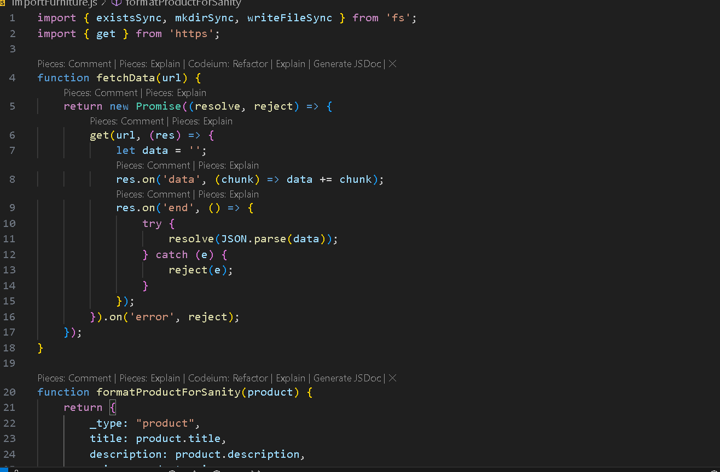**Hackathone Day3**

**API Integration Report**

**A report documenting**

* **API integration process.**
* **Adjustments made to schema.**
* **Migration steps and tools used.**

**Screen shorts of**

* **API calls.**
* **Data successfully displayed in the frontend.**
* **Populated sanity CMS fields.**
* **Code snippets for API integration and migration scripts.**

